Crypto-fun CTF (Capture the Flag)
Task:
You have five ciphertexts to decipher. For every encrypted message you decrypt, you will get a clue that will help you decrypt the next one, and a flag; capture these flags and keep them safe.
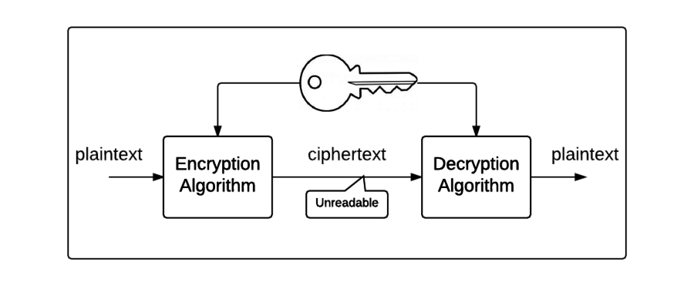

Encrypted message 1
“3 12 21 5 : 1 12 16 8 1 2 5 20 9 3 1 12 19 21 2 19 20 9 20 21 20 9 15 14 18 5 22 5 18 19 5 15 18 4 5 18 . 6 12 1 7 : 23 5 12 12 4 15 14 5”.
Hint: each letter has been replaced by the number that represents its position in the English alphabet.
Cipher text | 7 | 15 | 15 | 4 | 12 | 21 | 3 | 11
Plain text | g | o | o | d | l | u | c | k

For example:

Using the two tables below, decrypt the ciphertext by mapping the numbers to letters.
Plain text | a | b | c | d | e | f | g | h | i | j | k | l | m | n | o | p | q | r | s | t | u | v | w | x | y | z
Cipher text | 1 | 2 | 3 | 4 | 5 | 6 | 7 | 8 | 9 | 10 | 11 | 12 | 13 | 14 | 15 | 16 | 17 | 18 | 19 | 20 | 21 | 22 | 23 | 24 | 25 | 26

Cipher text | 3 | 12 | 21 | 5 | : | 1 | 12 | 16 | 8 | 1 | 2 | 5 | 20 | 9 | 3 | 1 | 12 | 19 | 21 | 2 | 19 | 20 | 9 | 20 | 21 | 20 | 9 | 15 | 14 | 18 | 5 | 22 | 5 | 18 | 19 | 5
Plain text
Cipher text | 15 | 18 | 4 | 5 | 18 | . | 6 | 12 | 1 | 7 | : | 23 | 5 | 12 | 12 | 4 | 15 | 14 | 5
Plain text

Great work! Now head to the next page to see how you can use the clue you just decrypted!

Well done!
Now that you’ve done a manual decryption you can head to https://cryptii.com/ to help you complete the following activities. Make sure to set Cryptii to Decode!

Encrypted Message 2
Dvoo wlmv! Blf szev wvxlwvw gsv urihg xrksvigvcg. Blfi xofv uli gsv ulooldrmt zxgrergb rh gsv ulooldrmt jflgv: "R xznv; R hzd; R xlmjfvivw". Urev rh gsv nztrx mfnyvi. Uozt: Hvxfiv xibkgltizksb rh z pvb kzig lu lmormv xbyvihvxfirgb.
Hint: The encryption algorithm that has been used to encrypt this message is the clue you just discovered!

Decrypted message 2

Clue for the next encrypted message

Flag

Encrypted message 3
Bjqq itsj! Dtz ijhnumjwji ymj xjhtsi hnumjwyjcy. "N hfrj, N xfb, N htsvzjwji" bjwj ymj btwix gd bmnhm Ozqnzx Hfjxfw xzhhnshyqd ijxhwngji tsj tk mnx anhytwnjx. Dtzw hqzj ktw ymj ktqqtbnsl fhynanyd nx ymj gttp "Inxhtzwxj ts Knwj fsi Xfqy". Nk dtz sjji f pjd, ywd Hfjxfw'x "Xmnky". Kqfl: Tzw inlnyfq btwqi nx hmfslnsl jajwdifd fsi dtzsl ujtuqj ns XYJR xzgojhyx fwj rfpnsl ymfy hmfslj mfuujs.

Decrypted message 3

Clue for the next encrypted message

Flag

Encrypted message 4
Bmgp iwii, dwp hjkdtmmmii bci ypdvi kdtmmmxjfo. Fqidwj lz Znozrjzz mx bci fcoltz jj "Iqngtcmwj wi Jnzz esl Neqb" vri pz gwmvxjl v rje xmupzv ginii wi xmm Xejavv hqkljz. Tszz xpzm asw bci kwgptedrl ixxnddxd kvr gm aszvy ljzz: lybkw://ber.hng-aiskz.gt.cf/twwyyhb/nuzimi-uwnx-fvy-vfqg-jjvxmso-fmy/. Bci Pmt mx bci schfjz jj Hwhtzbdrl Cihjzbvflpeym Xszznix wajjzzh fb olj Cimammwnbt sk Ejvhmnxjz. Apfo: Oljzz ewm ns riic hgwiwazgzzdxd, ldknbvp fvy WYMH gfzziwa dr ypz atzgh. Tvz sk bcir udkmb wi kwm ctc!

Decrypted message 4

Clue for the next encrypted message

Flag

Encrypted message 5
Wooidf apxi j ltyhehsttitWtle ajtcyednYucpe ohalsihethssb uastepe ha wiw c tns hnviy oseFaW eyhvno hatt!l e ehrteutn tcet.T aens hrxm fewi c taorue teUes frer g hpo eeydi iil!dehrd r hetoao nheuda roc.:ou esv

Decrypted message 5

Flag

Well Done!
You’ve completed the Challenge

